Engineering Geodesy

Lab 1: Communication with a total station via GeoCOM

Group 4
Evan Thomas
Yue Pan
Cyprien

Introduction
This report will illustrate the method and results of communicating with a total station (TSP) via a serial interface to perform automated measurements and data analysis. A small set of measurements will be taken, to provide insight into the prevalence of measurement errors within the device.

The method employed in this report can be useful in demonstrating a strategy for automation in an engineering setting where TSP measurements can be used to determine physical movement of various objects over a continuous interval, such as the movement of a building beside a construction site.

Method
A Leica TS60 total station was set up on a fixed pillar and levelled. The RS232 serial cable, with USB conversion adapter was used to interface between a laptop and the TSP. MATLAB was used to communicate over the serial interface by sending commands according to the GeoCOM protocol and interpreting the response.

A series of functions were written in MATLAB to perform:
Before taking the measurement, the program firstly established the connection between PC and the total station and then set the measurement mode and parameters.
When taking the measurement, the program requested that a user manually identify the locations of M prisms, after which a total of N repetitions ocurred which included:
- Directing the TSP to return to the M prisms in sequential order,
- Taking a new horizontal, vertical, and distance measurement,
- Instructing the TSP to change face,
- Repeating the measurement of each prism again in reverse sequential order.

In total, independent horizontal, vertical and distance measurements were taken, exclusive of the initial manual measurements. N is the number of measurement sets, M is the number of target prisms and 2 is for the dual-face measurements.

The MATLAB script doStatistics.m then calculated the adjusted horizontal angle (Hz), vertical angle (Hz) and distance (D) measurements together with the residuals and standard deviations according to ISO standard 17123-3, which are illustrated in the results.

Results
The experiment is conducted on Oct. 22th in HIL C 71.3 (approximate floor plan is shown in Fig.1). The automatic measurement results for Hz, V and D (4 targets and 3 sets) are shown in Table 1.

Table 1. Measurement result on 4 targets for three sets
measurement/target | 102 | 103 | 3 | 104 | std.
Hz [gon] | 0.0000 | 120.6539 | 165.9292 | 186.3799 | 0.0910 mgon
V [gon] | 85.6891 | 95.8227 | 99.9974 | 94.7684 | 0.0555 mgon
D [m] | 3.8352 | 12.9146 | 12.0717 | 11.3181 | 0.0726 mm

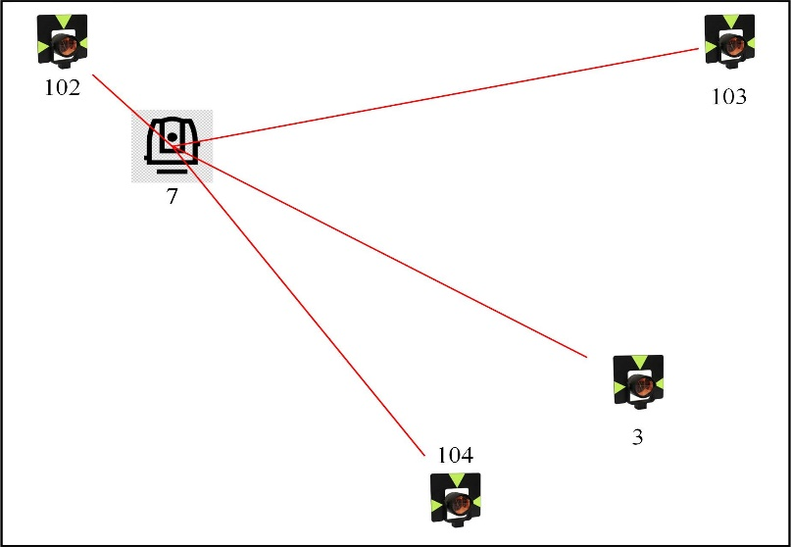
Fig 1. Approximate location of the total station and the prisms in the lab

During the statistics analysis, the first target (prism 102) is taken as the reference one so that its horizontal angle is set to be 0 while all the other prisms’ horizontal angle should minus the reference angle. The standard deviation is calculated from all the measurement sets for both face I and II.

Discussion

What should be the accuracy of the total station?

